Visual Guide to FlexViz

**BasicFlexoViz:**

Here is an overview of the visual components used inside the **BasicFlexoViz** application. The application contains one component – **BasicFlexoVizComponent**. It extends the **FlexGraph** component from the **ca.uvic.cs.chisel.flexviz** library project.

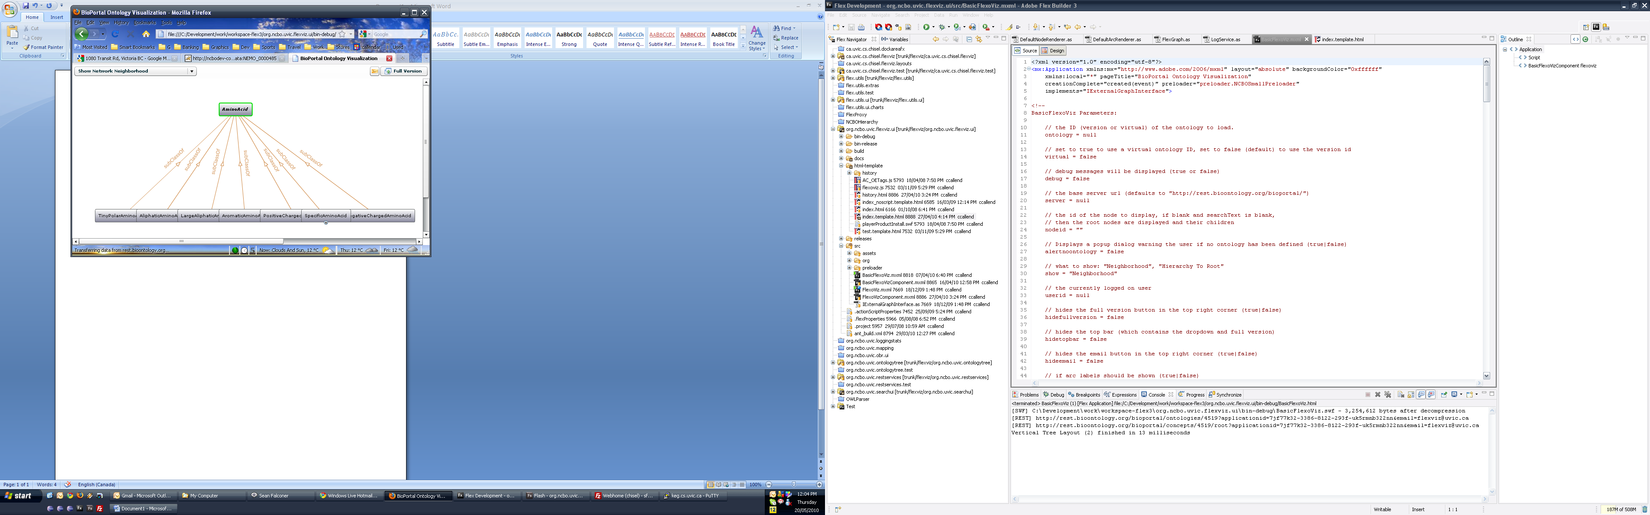

graphViewsCombo

topBar (HBox)

NCBOArcRenderer (extends renderers.DefaultArcRenderer)

NCBONodeRenderer (extends renderers.DefaultNodeRenderer)

nodesLayer (Canvas)

arcsLayer (UIComponent)

canvas

canvasWrapper

baseCanvas

FlexGraph (VBox)

**Full FlexoViz:**

Here is an overview of the full version of the **FlexoViz** application. The application contains a two components, the **FlexoVizOntologyTree** on the left (which extends from the **OntologyTree** class, in the **org.ncbo.uvic.ontologytree** project), and the **FlexoVizComponent** on the right (which extends the **ExtendedFlexGraph** component inside the **ca.uvic.cs.chisel.flexviz** project).

NCBOMenuBar

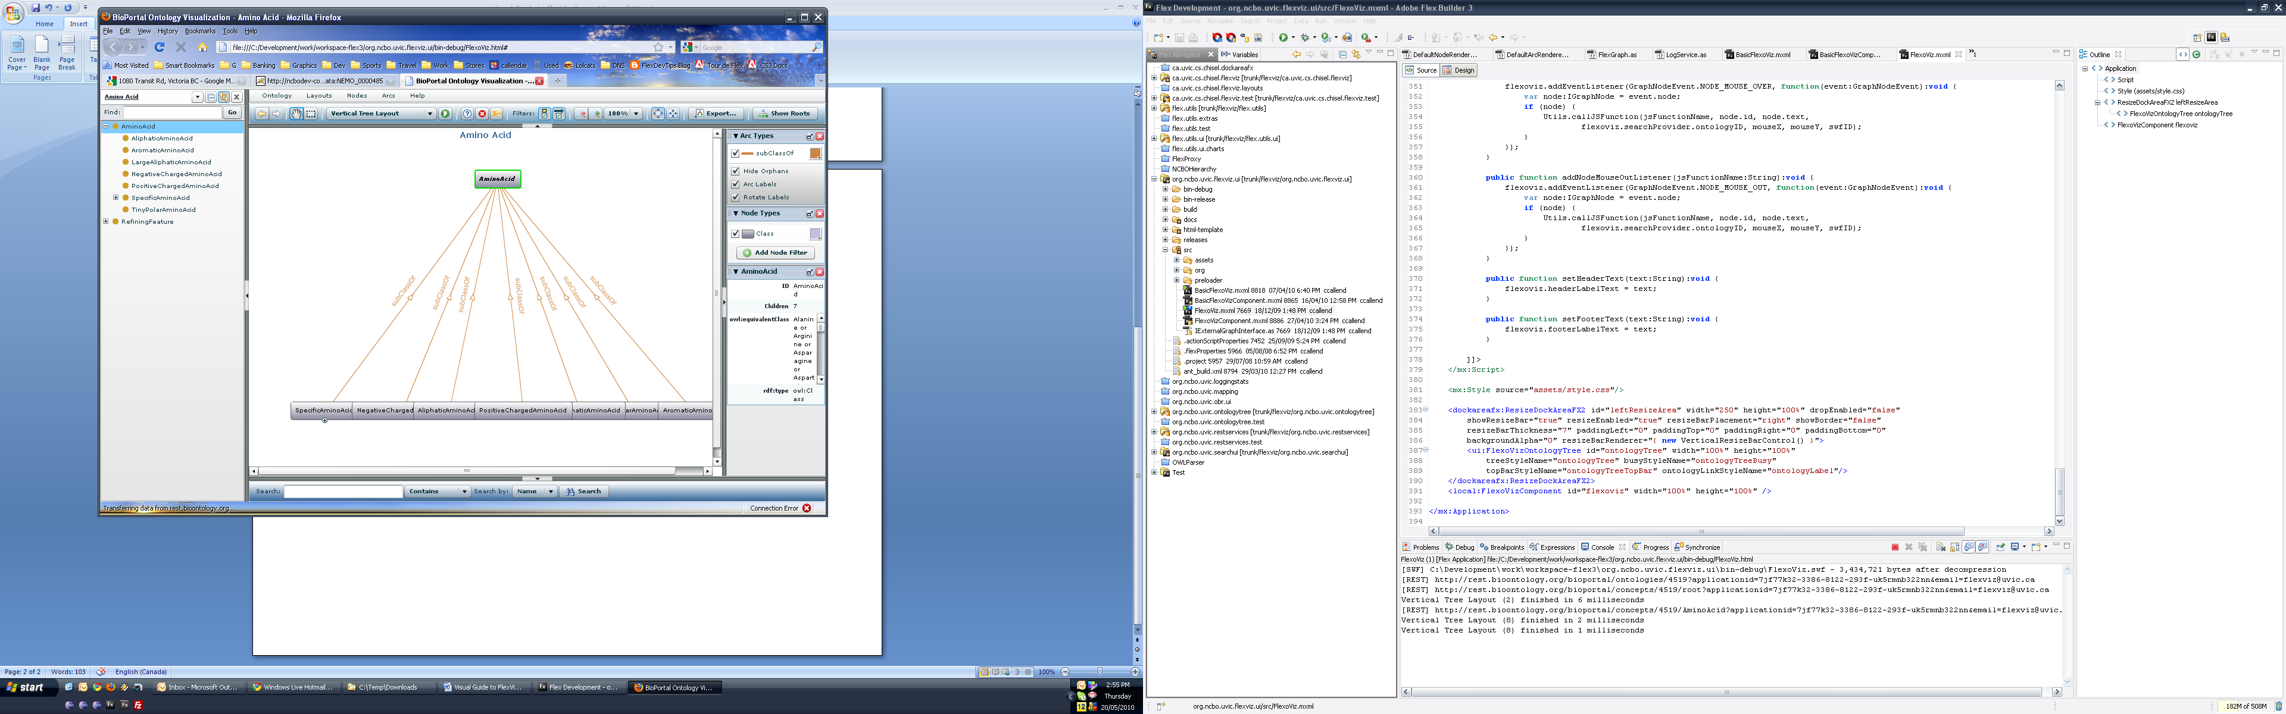

PropertiesPane

nodeFilterPane (filter.NodeFilterPane)

arcFilterPane (filter.ArcFilterPane)

searchBar (SearchBar)

rightResizePane

topResizeBar (in ExtendedFlexGraph)

FlexoVizOntologyTree (extends OntologyTree)